

**Ownership & Accountability Workshop**

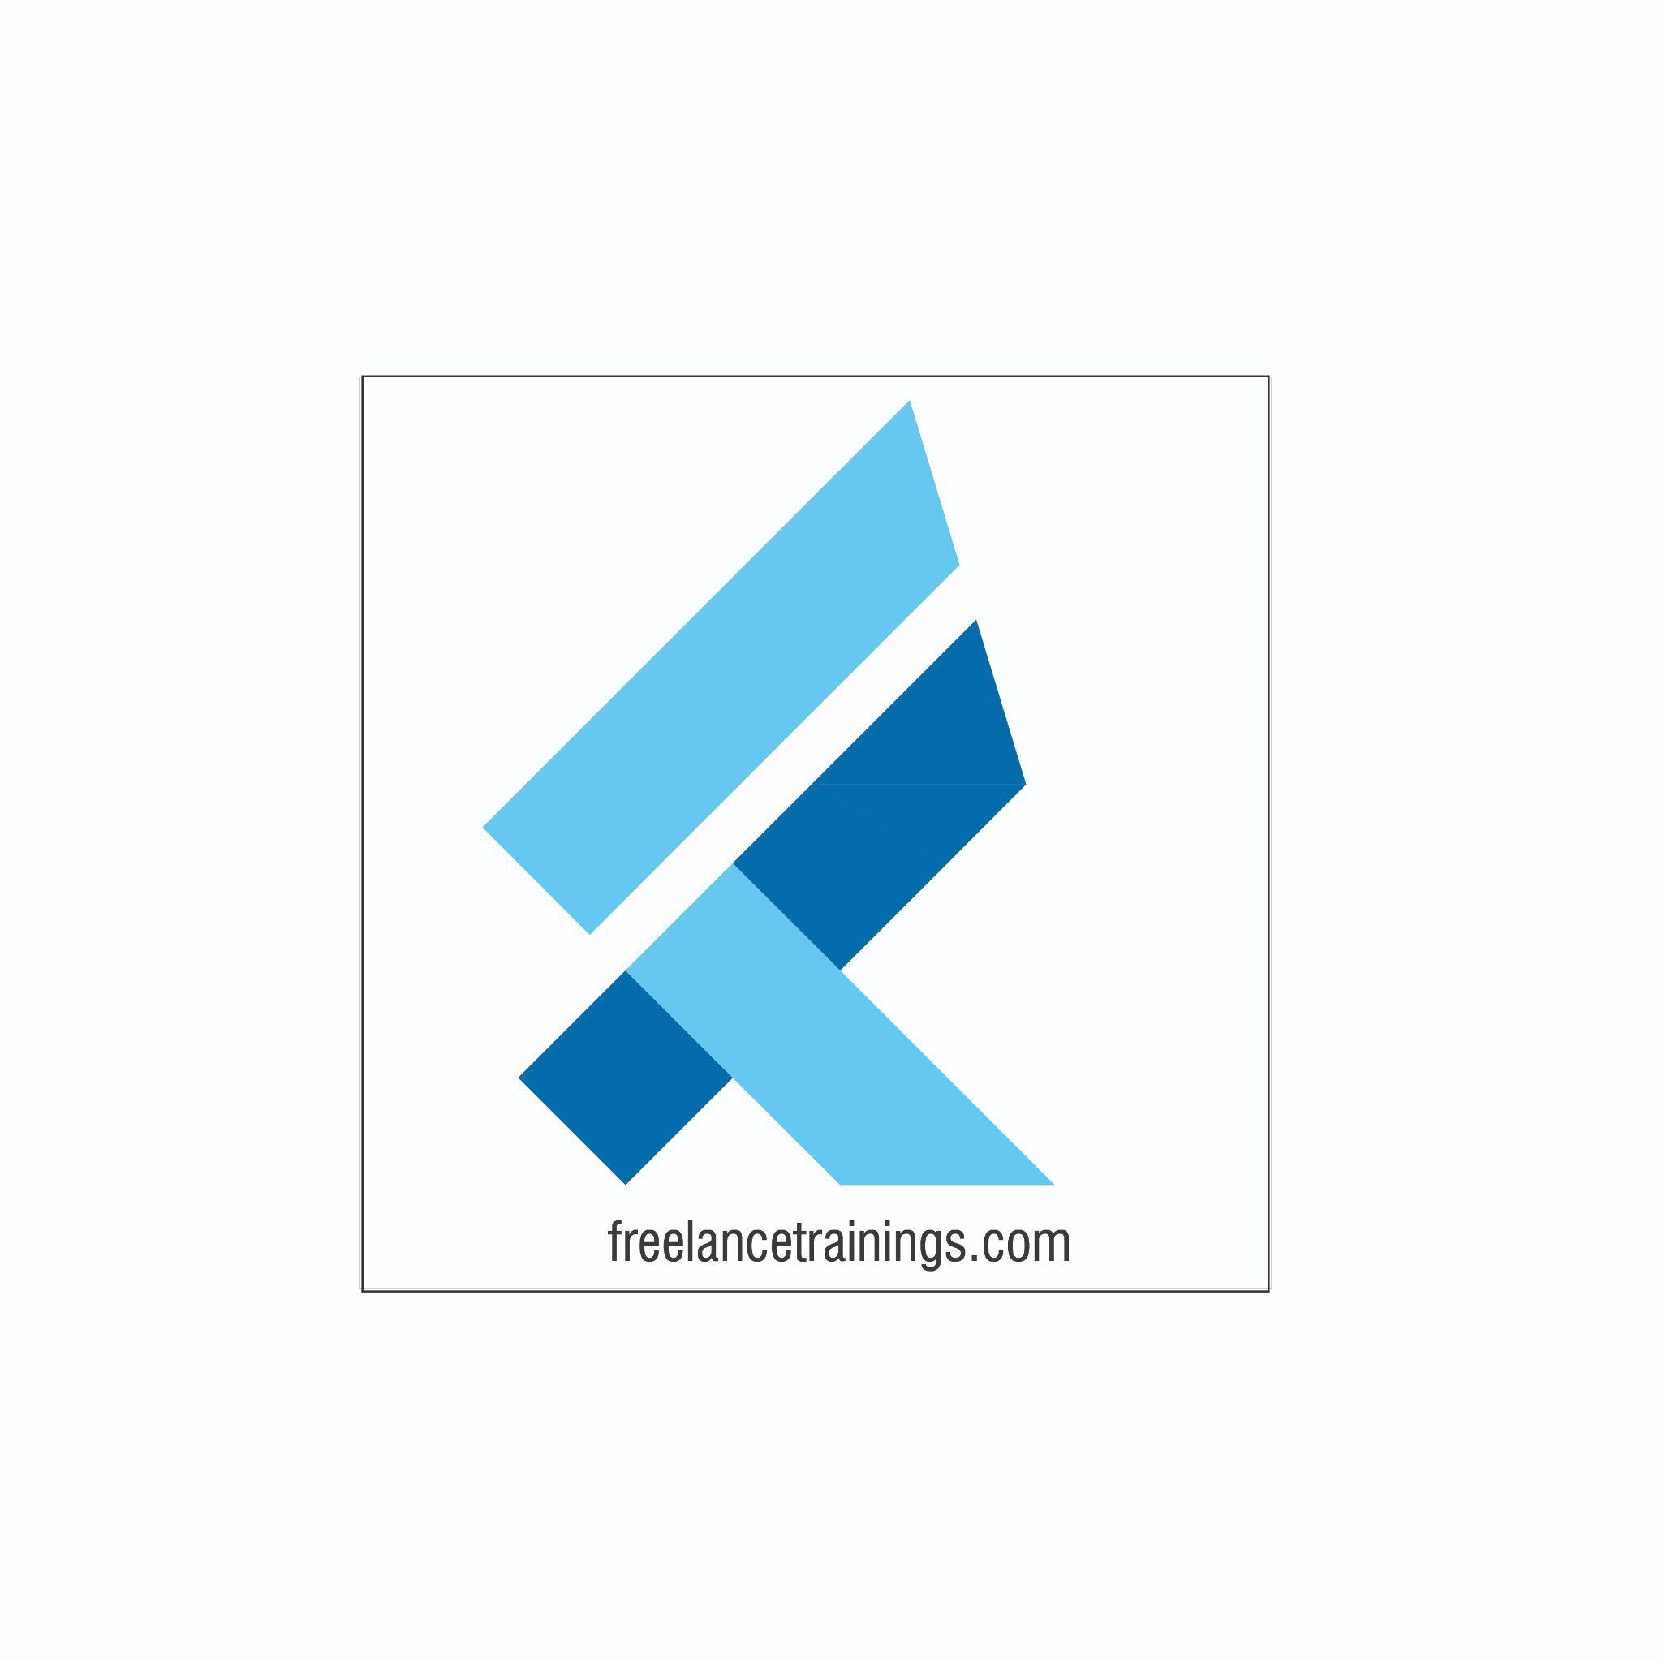" When a team takes ownership of its problems, the problem gets solved. It is true on the battlefield, it is true in business, and it is true in life”. - Jocco Willink

Ownership & Accountability Workshop

Duration: 1 Day

No of Participants: 25-30 Pax

Timing: 9:30 A.M- 5:30 P.M

Target Audience

* Individual Contributors
* Supervisors
* Team Managers
* Employees of any department

Workshop Objectives

* Understanding Ownership & Accountability
* Benefits of Accountability to the individuals & Organisation
* Being a solution Centric Professional
* Accountability Ladder (Accountable Vs Victim Approach)
* Developing a Growth Mindset
* Understanding the accountability cycle
* RACI Matrix & PDCA Model
* Personal Strength Analysis



Workshop Outline

|  |  |  |
| --- | --- | --- |
| **Sr. No.** | **Time** | **Topic** |
| 1 | 9:30 – 10:15 AM | **What’s In It for Me**   * Workshop Intro & Agenda * Ground Rules * Icebreaker * Facilitator Intro * Participant Intro & Expectations |
| 2 | 10:15 -10:30 AM | **Pre-Training Assessment** |
| 3 | 10:30 -11:15 AM | **Understanding Ownership & Accountability- Part 1**   * Meaning & Context * Performing to Higher performing * Becoming a Solution Centric professional * Areas to build Accountability |
| 4 | 11:15- 11:30 AM | **First Tea Break** |
| 5 | 11:30- 12:00 AM | **Understanding Ownership & Accountability- Part 2**   * Accountability pathways * Overcoming Blames & Excuses * Accountable & Unaccountable Behaviours * Accountability & Ownership Scenarios |
| 6 | 12:00 -12:30 AM | **Importance of Taking Ownership & Accountability**   * Accountability Ladder (Accountable Vs Victim) * Importance of Ownership |
| 7 | 12:30 -1:30 PM | **Opportunities for exercising ownership & accountability**   * Mindset is Everything * Fixed Vs Growth Mindset * See IT to DO IT Model * Strategies to building Ownership & Accountability |
| 8 | 1:30 - 2:00 PM | **Lunch Break** |
| 9 | 2:00 - 2:15 PM | **Energiser** |
| 10 | 2:15 - 3:00 PM | **Key Stages of Accountability Cycle**   * 5 Stage accountability cycle * Set Goals * Develop Action Plans * Conduct review meeting * Appraise performance |
| 10 | 3:00 - 3:45 PM | **Learn lessons of Unsuccessful Outcome and develop a plan to overcome it**   * RACI Matrix (Responsible, Accountable, Consulted & Informed) * Steps to create RACI Matrix * PDCA Cycle (Plan, DO Check & Act) |
| 11 | 3:45 - 4:00 PM | **Second Tea Break** |
| 12 | 4:00 - 4:30 PM | **Personal Strength Analysis**   * SWOT Analysis understanding * Conducting personal SWOT Analysis |
| 13 | 4:30 – 4:45 PM | **Post-Training Assessment** |
| 14 | 4:45 – 5:30 PM | **Closing**   * Feedback forms * Q& A (If any) * Closing Video (If any) * Group Photo |

*This Workshop outline is based on the industry best practices and will be customised after discussion with the client. *